The physical layer refers to the physical communication medium and the technologies to transmit data across that medium.
The physical layer refers to the physical communication medium and the technologies to transmit data across that medium.



NATIONAL SKILL TRAINING INSTITUTE (NSTI) KOLKATA, DASNAGAR, HOWRAH

LESSON PLAN
NAME:- Ankita singh TRADE/ROLL NO.- CITS/CSA/25-26/Y/1420
UNIT/LESSON NO:- 01 DATE & TIME:- 10-10-2025
- PREPARATION

TITLE/TOPIC:- OSI MODEL

OBJECTIVES: At the end of the lesson trainee shall able to -
a). Define the OSI Model.
b). Identify and describe the 7 layers of the OSI Model .
TEACHING AIDS : WHITE BOARD, Marker , Projector, Powerpoint ETC.
INTRODUCTION:
REVIEW / LINK/ MOTIVATION :- Motivate by the Examples.
- PRESENTATION :
OBJECTIVES | INFORMATION POINTS | SPOT HINTS
DEFINITION  Physical layer | The Open Systems Interconnection (OSI) model describes seven layers that computer systems use to communicate over a network. The OSI model is divided into seven distinct layers, each with specific responsibilities, ranging from physical hardware connections to high-level application interactions.  The physical layer refers to the physical communication medium and the technologies to transmit data across that medium. | NETWORK  COMMUNICATION

OBJECTIVES | INFORMATION POINTS | SPOT HINTS
datalink layer  network layer  Transport layer  Session layer  Presentation layer  Application layer | The data link layer refers to the technologies used to connect two machines across a network where the physical layer already exists  The network layer is concerned with concepts such as routing, forwarding, and addressing across a dispersed network or multiple connected networks of nodes or machines.  The primary focus of the transport layer is to ensure that data packets arrive in the right order, without losses or errors, or can be seamlessly recovered if required. Flow control, along with error control, is often a focus at the transport layer. (e.g. video streaming).  The session layer is responsible for network coordination between two separate applications in a session  Presentation layer  The presentation layer is primarily concerned with the syntax of the data itself for applications to send and consume. presentation layer.  Application layer  The application layer is concerned with the specific type of application itself and its standardized communication methods. | Connects two machines  Multiple connected networks  Data packets should be arrive in right order  coordination  standardized communication
- APPLICATION : a)...what is datalink layer).....what is the use of APPLICATION LAYER IN OSI MODEL
c)..WHAT IS physical layer in OSI model?...

SUMMARY : To repeat the objectives/main points once again.
a)..Repeat all the objectives in short

- TEST/QUESTIONS : a).....when was OSI model introduced?..................
b).......why is OSI model important
c).....what is the of transport layer?......
Make a presentation on OSI model describing layers in short.
Reference:....google , class notes etc… NEXT LESSON: internetworking................



NATIONAL SKILL TRAINING INSTITUTE (NSTI) KOLKATA, DASNAGAR, HOWRAH

INFORMATION SHEET

TITLE/TOPIC: SKILL AND ITS BASIC ELEMENTS

INFORMATION: he Open Systems Interconnection (OSI) model describes seven layers that computer systems use to communicate over a network. The OSI model is divided into seven distinct layers, each with specific responsibilities, ranging from physical hardware connections to high-level application interactions.
Each layer of the OSI model interacts with the layer directly above and below it, encapsulating and transmitting data in a structured manner. This approach helps network professionals troubleshoot issues, as problems can be isolated to a specific layer. The OSI model serves as a universal language for networking, providing a common ground for different systems to communicate effectively.
The OSI model was the first standard model for network communications, adopted by all major computer and telecommunication companies in the early 1980s. It was introduced in 1983 by representatives of the major computer and telecom companies, and was adopted by ISO as an international standard in 1984.
The modern Internet is not based on OSI, but on the simpler TCP/IP model. However, the OSI 7-layer model is still widely used, as it helps visualize and communicate how networks operate.
Why Is the OSI Model Important?
The OSI model provides several advantages for organizations managing networks and communications:
- Shared understanding of complex systems: OSI offers a universal language for networking, enabling different network devices and software to communicate. By dividing communication into seven distinct layers, it allows network professionals to isolate and troubleshoot problems effectively.
- Faster research and development: Developers can focus on improving specific layers without affecting others, leading to more rapid innovations. This modular approach enables specialization and enables different teams to work on various aspects of network communication simultaneously.
- Flexible standardization: The model’s layered approach allows for the integration of new technologies at any layer without disrupting the overall network structure. This ensures compatibility across different devices and protocols, ensuring long-term viability and scalability of network infrastructure.
OSI Model Explained: The OSI 7 Layers
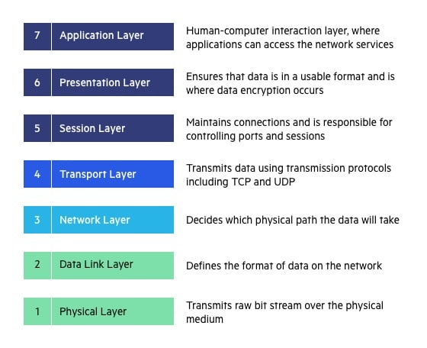

WORKMANSHIP:

